**Fluke Bots Usage tracking report**

**Table of Contents**

Introduction to Fluke Bot Usage Tracking report ...........................................................................2

Why are Bot Usage tracking report Used?.....................................................................................2

Understanding Bot Usage Tracking ................................................................................................2

Key Components of Bot Usage Tracking in Azure ..........................................................................2

Benefits of Bot Usage Tracking in Azure ........................................................................................2

Fluke Tech Support GPT .................................................................................................................3

Fluke Site GPT ................................................................................................................................6

PLM Chat BOT ................................................................................................................................9

Voice to Text .................................................................................................................................11

VOC Summary................................................................................................................................12

Document Translator.....................................................................................................................13

UBI Chat Bot..................................................................................................................................14

**Introduction to Fluke Bot Usage Tracking report**

In the evolving landscape of digital communication, organizations increasingly rely on chatbots to enhance customer interactions, streamline processes, and provide efficient services. Microsoft Azure, a comprehensive cloud computing platform, offers a sophisticated environment for developing, deploying, and managing these chatbots. To ensure optimal performance and gather insights into user interactions, Azure provides a robust Bot Usage Tracking Report.

**Understanding Bot Usage Tracking**

Bot Usage Tracking involves the systematic monitoring and analysis of interactions between users and chatbots deployed on the Microsoft Azure platform. It encompasses a range of metrics and data points that offer valuable insights into the effectiveness, efficiency, and user satisfaction of the deployed bot.

**Key Components of Bot Usage Tracking in Azure**

**User Interactions Monitoring:** Azure enables the tracking of user interactions with the chatbot, providing a detailed breakdown of conversation flows.

**Integration with Azure Analytics Services:** The usage tracking data seamlessly integrates with Azure's analytics services, enabling organizations to correlate bot usage with broader business metrics and gain a comprehensive understanding of the impact of chatbots on overall operations.

**Benefits of Bot Usage Tracking in Azure**

**Tracking the Performance of the Tool:** Insights from usage tracking enable organizations to tailor their chatbots to better meet user needs, leading to an improved and more satisfying user experience.

**Enhanced User Experience:** Users can provide their feedback, whether the response is appropriate or not.

**Data-Driven Decision Making:** Leveraging the power of analytics, organizations can make data-driven decisions to optimize resources, improve bot capabilities, and align chatbot strategies with business objectives.

**Continuous Improvement:** Bot Usage Tracking in Microsoft Azure facilitates a cycle of continuous improvement, allowing organizations to iterate on their chatbot implementations, stay ahead of user expectations, and adapt to changing business requirements.

1. **Fluke Tech Support GPT**

Fluke Tech Support GPT is for internal Fluke techies, Fluke Tech Support GPT helps them looking for Knowledge base, web site data, SharePoint locations can review all chats with this tool.

**Architecture Diagram**

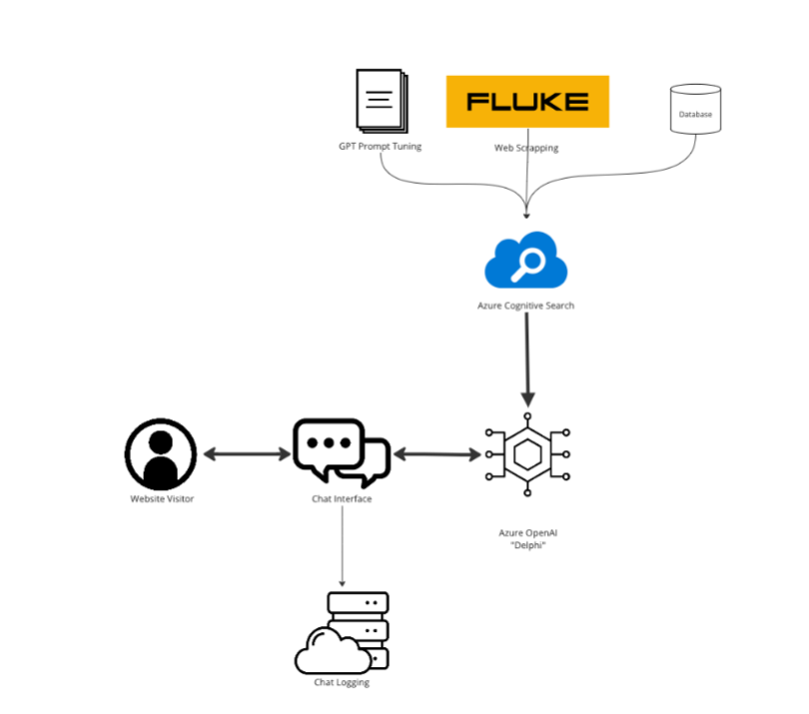

Fluke Tech Support uses a chatbot or a conversational agent based on a GPT (Generative Pre-trained Transformer) model to capture sessions created by users. The details of these sessions are then stored in an Azure MySQL database.

**Conversational Agent (GPT):**

The GPT model, possibly a variant like GPT-3, is utilized as a chatbot or conversational agent. It understands and generates human-like responses based on the input it receives from users during support sessions.

**Session Management:**

The system should manage user sessions, keeping track of interactions and maintaining context during the conversation. This involves capturing user inputs, processing them using the GPT model, and managing the flow of the conversation.

**Data Capture:**

Relevant information from each user session, such as user queries, responses generated by the GPT model, timestamps, and any other pertinent details, is captured and prepared for storage.

**Azure MySQL Database:**

An Azure MySQL database is used to store the captured session details. The database schema includes tables to store information like user IDs, timestamps, session content, and any other necessary metadata.

**Data Storage and Retrieval:**

Sessions' details are inserted into the MySQL database for persistent storage. Additionally, the system might include mechanisms to retrieve historical session data for analysis or reference.

Fluke Tech Support GPT stores the Chat details i.e ChatId, Chat history, time of the chat conversation

in the Azure SQL Database.

Fluke Tech Support GPT captures the sessions created by users and store those details in Azure MYSQL database.

|  |  |
| --- | --- |
| Resource Group Name | flk-techsupport-gpt-prd |
| Database Name | db-flktsgpt-prd-001.database.windows.net |
| Table Name | tblbotchat |

**Table structure and description:**

**Tblbotchat:**

|  |  |  |
| --- | --- | --- |
| Column Name | Column Type | Description |
| IDNUM | Number | Primary key – Unique value for the table |
| ChatId | VARCHAR | Stores ChatID (Unique number generated from Front end for each user created sessions) |
| ChatHistory | BLOB | Stores User asked question and the Bot responses |
| Updated_date | TIMESTAMP | Time of the Chat initiated |

**Sample data from database**

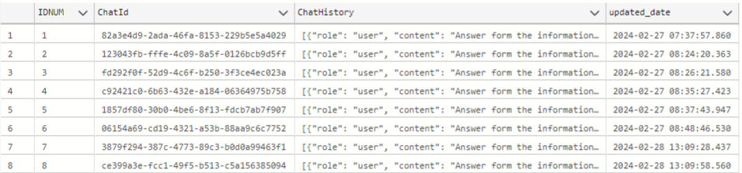

**Query to get the count for the session created by the user**

|  |
| --- |
| select COUNT(*) AS 'No of Hits',  CAST([updated_date] AS DATE) AS Date  from tblBotChat  group by CAST([updated_date] AS DATE) order by Date desc |

**Sample PowerBI report for Fluke Tech Support GPT:**

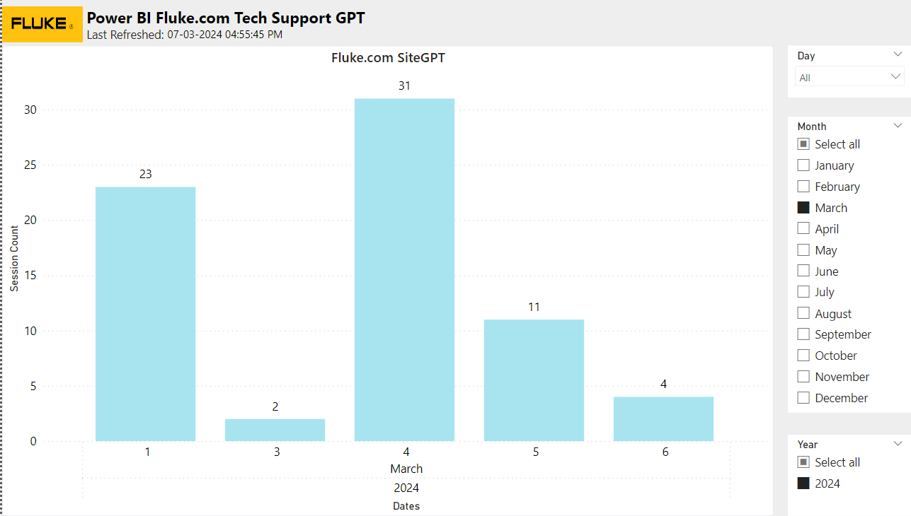s

1. **Fluke Site GPT**

Fluke Site GPT is for external customers, it can even help them look for product prices, and customers can review all chats with our tool. Fluke Site GPT can be directed to answer as a representative of the Fluke brand and can be prompted to answer certain types of questions in a certain way or direct people to a Fluke representative as needed. Additionally, customers can add intro text and links/buttons to the customer-facing chat box to promote important messages or promotions, and the tool's creativity can be adjusted, and additions can be made to user/system prompts to adjust responses.

This tool can also help customers compare Fluke products, purchase products on Fluke Corporation: Fluke Electronics, Calibration and Networks, find resources and technical support for products, locate distributors where they can purchase products, download software and firmware, find manuals and other product documentation, and find customer service and technical support contact information. With Fluke Site GPT, customers can rest assured that they will always have the information they need right at their fingertips.

**Architecture Diagram**



Fluke Site GPT uses a chatbot or a conversational agent based on a GPT (Generative Pre-trained Transformer) model to capture sessions created by users. The details of these sessions are then stored in an Azure MySQL database.

**Conversational Agent (GPT):**

The GPT model, possibly a variant like GPT-3, is utilized as a chatbot or conversational agent. It understands and generates human-like responses based on the input it receives from users during support sessions.

**Session Management:**

The system should manage user sessions, keeping track of interactions and maintaining context during the conversation. This involves capturing user inputs, processing them using the GPT model, and managing the flow of the conversation.

**Data Capture:**

Relevant information from each user session, such as user queries, responses generated by the GPT model, timestamps, and any other pertinent details, is captured and prepared for storage.

**Azure MySQL Database:**

An Azure MySQL database is used to store the captured session details. The database schema includes tables to store information like user IDs, timestamps, session content, and any other necessary metadata.

**Data Storage and Retrieval:**

Sessions' details are inserted into the MySQL database for persistent storage. Additionally, the system might include mechanisms to retrieve historical session data for analysis or reference.

Fluke Site GPT stores the Chat details i.e ChatId, Chat history, time of the chat conversation

in the Azure SQL Database.

Fluke Site GPT captures the sessions created by users and store those details in Azure MYSQL database.

|  |  |
| --- | --- |
| Resource Group Name | Flk-SiteGPT-Prod |
| Database Name | flk-db-sitegpt-prd-002.database.windows.net,1433 |
| Table Name | tblbotchat |

**Table structure and description:**

**Tblbotchat:**

|  |  |  |
| --- | --- | --- |
| Column Name | Column Type | Description |
| IDNUM | Number | Primary key – Unique value for the table |
| ChatId | VARCHAR | Stores ChatID (Unique number generated from Front end for each user created sessions) |
| ChatHistory | BLOB | Stores User asked question and the Bot responses |
| Updated_date | TIMESTAMP | Time of the Chat initiated |

**Sample data from database**



**Query to get the count for the session created by the user**

|  |
| --- |
| select COUNT(*) AS 'No of Hits',  CAST([updated_date] AS DATE) AS Date  from tblBotChat  group by CAST([updated_date] AS DATE) order by Date desc |

**Sample PowerBI report for Fluke Site GPT:**

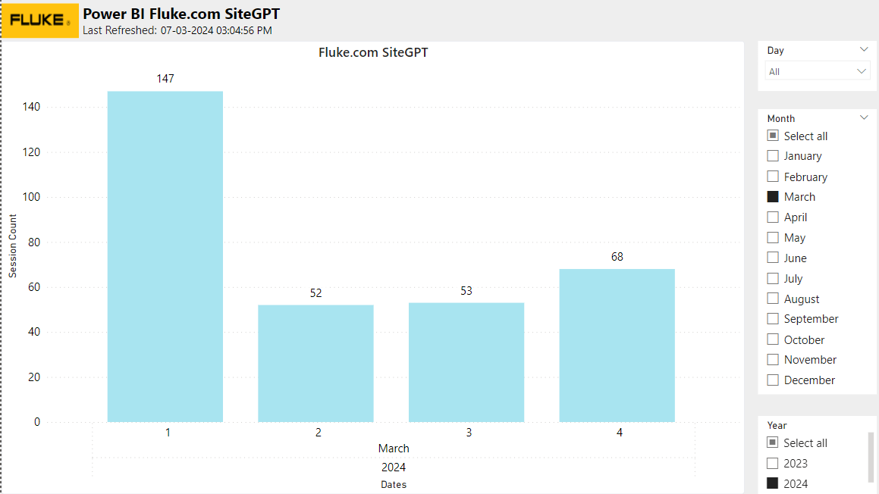

1. **PLM Chat Bot**

**Approach**

1. The Data from SharePoint and Excel sheets are stored in the Azure Blob storage using a Power Automate flow which makes it easier to synchronize information automatically without needing to do any manual triggers.

2. The Data which is stored in Blob is then connected to Azure Cognitive search service where our indexer indexes all the data and multiple indexers are run to make the data ready to be queried by the user.

3. The Open AI’s GPT 3.5 Model is deployed and connected to one of the indexes which contains all the required information.

4. Whenever a user asks a question to the user it will be queried to cognitive search and the ranked results generated by it is used by LLM to generate required answer.

5. The WebApp being deployed is also connected to Azure Cosmos DB to store the chat history for future analysis.

**Approach for links**

1. The chatbot was added with a feature of showing links of the work instruction as a citation and this section will discuss how we achieved that.

2. We first manually collected the links and names of the work instruction in a excel sheet. 3. This excel can be found here.

4. We have a power automate flow set up for this location which will detect any changes of modification to the file.

5. This data is stored in a azure table storage with name “links” in the storage account.

6. We use Refresh_PLM_Data notebook in the databricks and run it everyday to push any new links into the table storage.

7. The code will not do anything if the links are already present in the table and push only new data.

Architecture

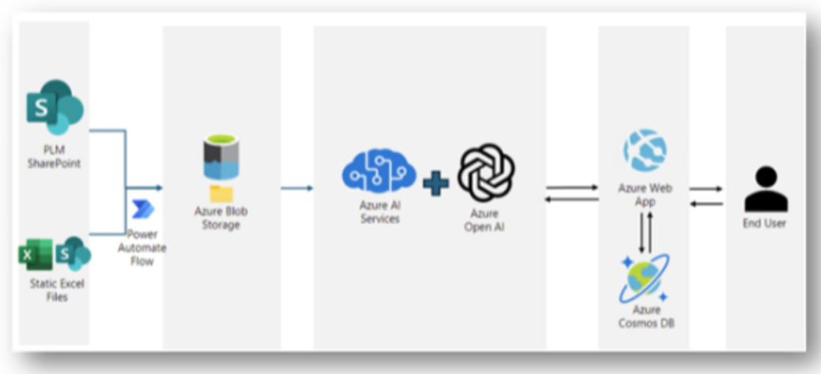

**Data Sources**

Storage account name: **plmchatbotprod**

Containers:

1. plm-chatbot: Folders:

a. /archive-plm: Contains the PLM archived data files with cool tier. Files in this contains full old data with all the extensions.

b. /plm-data: Contains the original source data pulled from sharepoint for PLM. Files under this will contain only required extensions meant to be considered as an input to the bot (i.e., .pdf, .csv)

c. /cosmosdb-data/latestData: Contains the cosmos db fresh data tables. This folder can be used for the analytics purpose of the responses.

d. /cosmosdb-data/archive-cosmosdb: This folder contains the older archive/backup of the latestData folder and all files of the the folders will be in cool tier.

2. faq: This container contains a single file which has the faq document and refreshes when new data comes. It is connected with the PLM_FAQ_Prod power automate flow.

3. links-excel: This container contains a single file named “links.xlsx” which contains FileName and FileLink Mapped to each other. It is connected with the PLM_Links_Prod power automate flow.

1. locations: This container contains a single file which contains various attributes with their location

location of data stored: **plmchatbotprod /plm-chatbot/cosmosdb-data/latestData**

1] plmconversations

2] plmhistoricalconversations

3] plmnoanswerconversations

**Steps for loading the data into Power BI :** 

**Sample PowerBI report for PLM Chat Bot:**

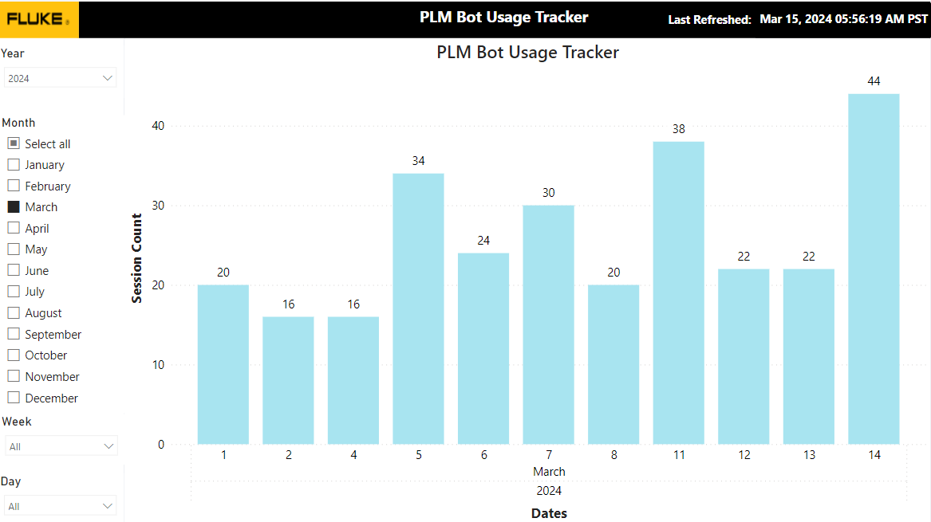

1. **Voice to Text Summary**

**Steps for loading the data into Power BI :**



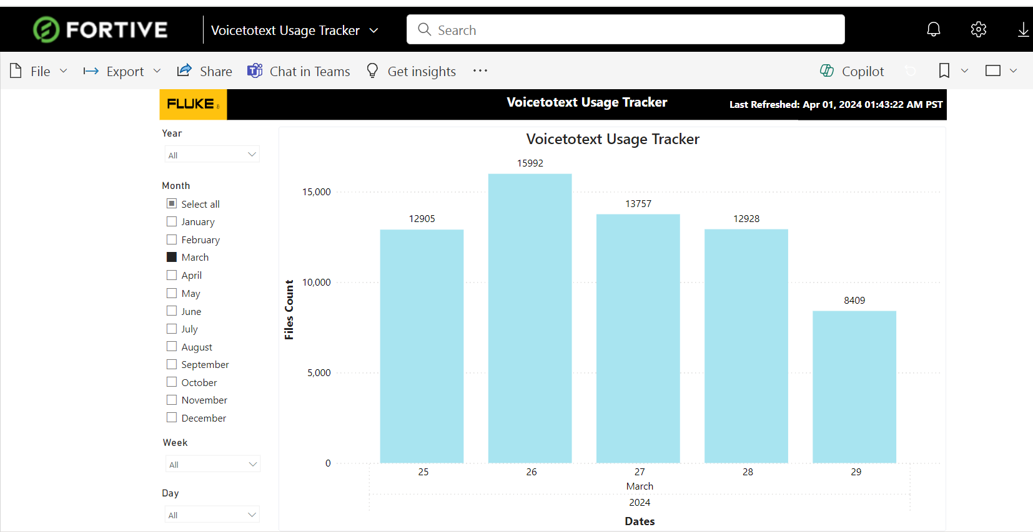

1. **VOC Summary Chatbot**

An AI tool designed to summarize and query video content from a Voice of Customer (VOC) database, named Enjoy HQ. The tool will feature a user-friendly interface allowing product owners, new product development teams, quality control teams, and continuous improvement teams to request video summaries based on transcripts. It will enable users to specify summary length and focus on specific themes.

The product aims to be broadly available to all internal Fluke users requiring the functionality. It should provide timely, adjustable, and customizable summaries with options to export results as PDF documents or PowerPoint presentations. Additionally, the tool will include usage tracking to monitor adoption and application, with success measured by user engagement and satisfaction.

**Architecture Diagram:**

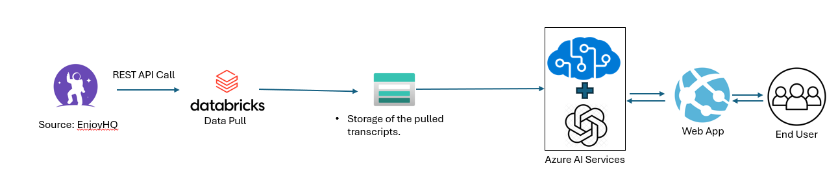

User responses and chat history are stored in Azure cosmos DB

Cosmos DB account name : **flk-voc-cosmosdb-prod**

Container name : **db_conversation_history**

Table name : **conversations**

**Power BI report :**

<https://app.powerbi.com/groups/6fec84af-8245-4738-b317-f29326432ae3/reports/52bf3ce4-a208-4ac0-8ba6-53fba6a170b9?ctid=0f634ac3-b39f-41a6-83ba-8f107876c692&pbi_source=linkShare>

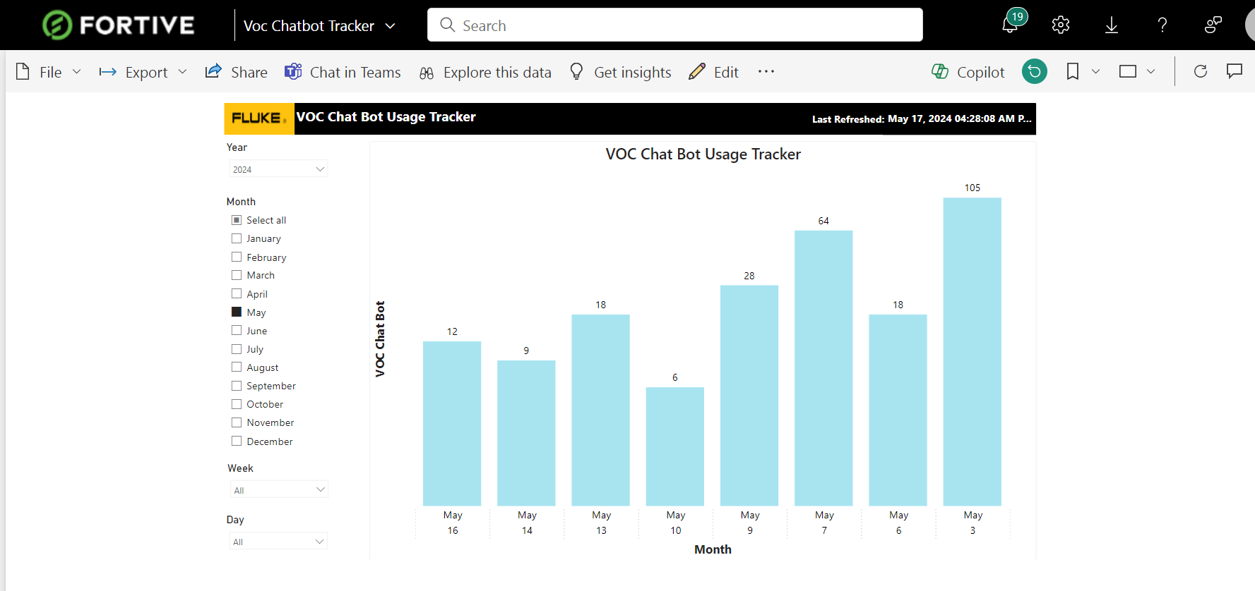

1. **Document Translator**

**Description:**

The AI application translates documents from one language to other languages. It supports most of the common formats such as doc, xls, doc, ppt, txt etc.

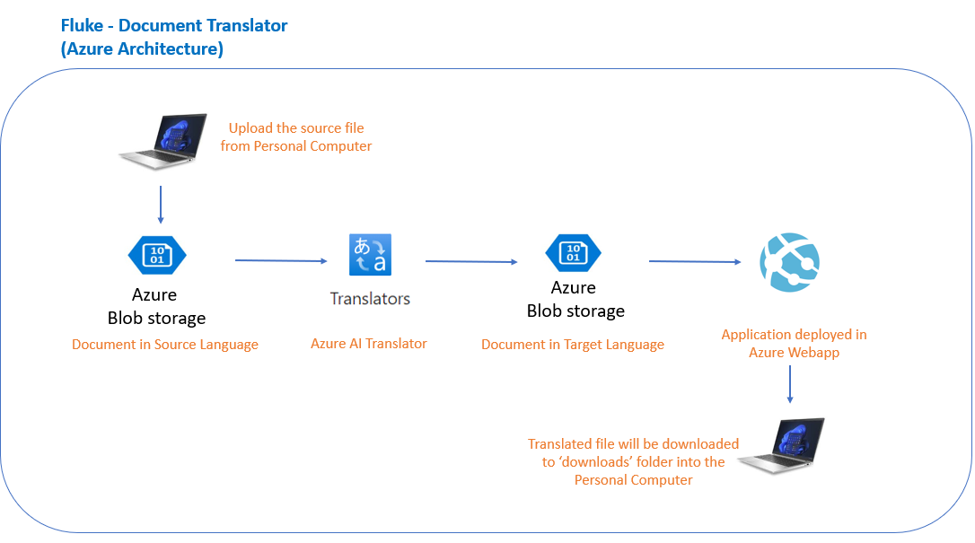

**URL :** flkdoctransln.azurewebsites.net

**App Service :** flkdoctransln

**AI Translator :** doctransln

**Azure Storage** : flkdoctransln

**Metadata :** https://portal.azure.com/#view/Microsoft_Azure_Storage/ContainerMenuBlade/~/overview/storageAccountId/%2Fsubscriptions%2F52a1d076-bbbf-422a-9bf7-95d61247be4b%2FresourceGroups%2Fflk-doctranslation-dev%2Fproviders%2FMicrosoft.Storage%2FstorageAccounts%2Fflkdoctransln/path/flkdoctransltrmetadata/etag/%220x8DC2B61990431ED%22/defaultEncryptionScope/%24account-encryption-key/denyEncryptionScopeOverride~/false/defaultId//publicAccessVal/None

Usage data are stored as a csv file in Blob storage. where Power BI report is created from the medata data file.

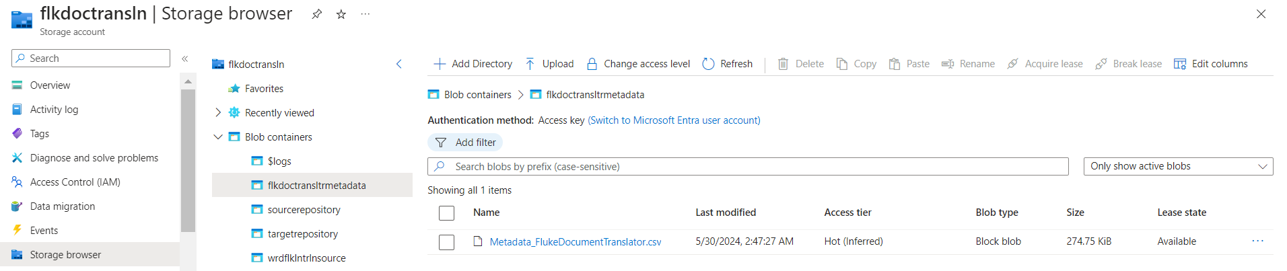

**Power BI link:**

https://app.powerbi.com/groups/me/reports/1eb6b13e-1fcd-4b85-b1da-731cbf0f240b/ReportSectionfcc11e327015a48ceb49?ctid=0f634ac3-b39f-41a6-83ba-8f107876c692&experience=power-bi

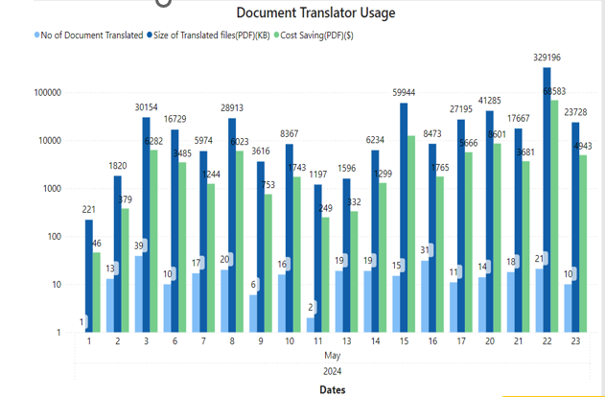

1. **UBI Chatbot**

With an abundance of data in the UBI SharePoint website, navigating and locating specific information had become increasingly cumbersome and time-consuming. With multiple files, folders and pages the website was full of useful data being uploaded by people from multiple disciplines.

UBI stands for Unified Business Intelligence and is an internal fluke project. UBI is Unified, Governed, and Integrated modern data analytics and reporting platform which Unlocks data across organizational, regional, and project driven silos.

We built an Open AI’s GPT powered Chatbot capable of answering any question related to UBI project that is present in the UBI SharePoint website. This Chatbot was built in Microsoft Azure and was also connected to Purview studio to answer questions based on different datasets

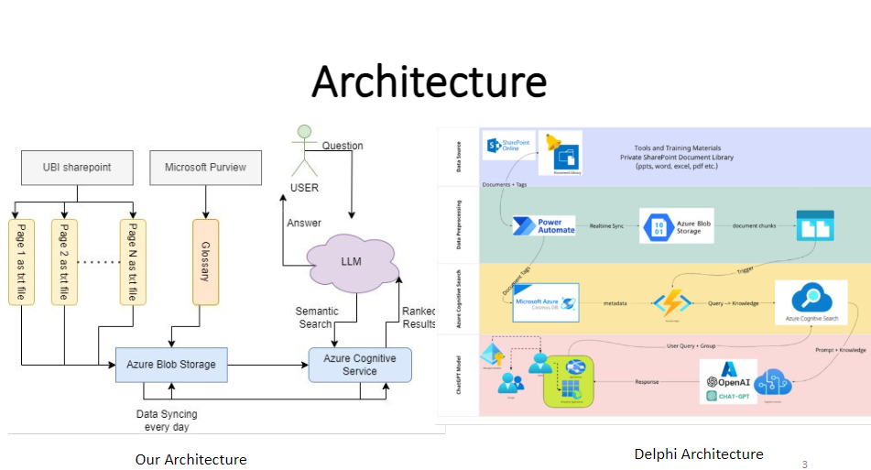

User responses and chat history are stored in Azure cosmos DB

Resource group name : **FLK-UBICHATBOT-PROD**

Cosmos DB account name : **db-ubichatbot**

Container name : **conversations**

Table name : **db_conversation_history**

**Power BI link:**

https://app.powerbi.com/groups/6fec84af-8245-4738-b317-f29326432ae3/reports/4338d9ec-1045-4fdf-b9bc-bb3013bc8f22/ReportSection30575c8415d74a191c81?experience=power-bi

